Elegant Décor & Rentals
Luxury Rentals for Unforgettable Events
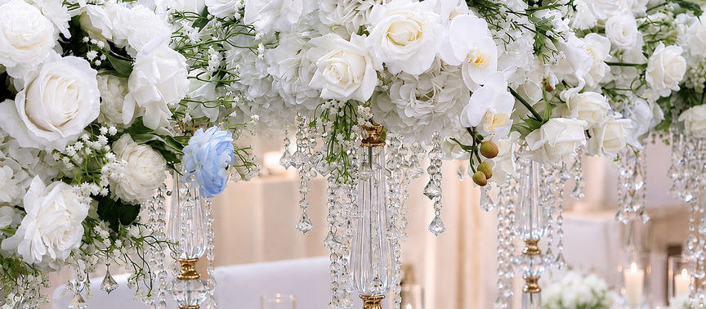
PRICING & INVESTMENT GUIDE
A transparent framework for building a custom celebration.
LUXURY WEDDINGS • SOCIAL EVENTS • SIGNATURE RENTALS
Elegant Decor & Rentals • (413) 627-1042 • elegantdecors7@gmail.com • Western Massachusetts

1. How Pricing Works
Every event is priced from the approved scope, quantities, design complexity, venue access, labor, transportation, and specialty product required. Exact pricing belongs in your written proposal and invoice.
Important
No prices have been invented in this guide. Fill in your approved starting prices below before sharing it with clients.

2. Suggested Investment Categories
DESIGN CONSULTATION | Starting at $________
CEREMONY DESIGN | Starting at $________
RECEPTION FOCAL INSTALLATION | Starting at $________
SWEETHEART / HEAD TABLE | Starting at $________
CENTERPIECE COLLECTIONS | Starting at $________ per table
LUXURY LINENS / TABLETOP | Starting at $________ per table
DELIVERY & INSTALLATION | Quoted by location, access, crew size, and schedule
STRIKE / RETRIEVAL | Quoted by event end time, access, labor, and distance

3. Package Framework
ESSENTIAL COLLECTION | Starting at $________  Best for focused décor in one or two priority areas. Include only approved items listed in the proposal.
SIGNATURE COLLECTION | Starting at $________  Best for coordinated ceremony and reception styling with a larger rental and floral scope.
FULL TRANSFORMATION | Starting at $________  Best for immersive room design, substantial installations, custom details, and extended production labor.

4. Common Factors That Affect Investment
- Guest count and number of tables
- Fresh floral market prices, season, and availability
- Custom fabrication, specialty structures, and personalized items
- Ceiling height, hanging installations, rigging, and venue restrictions
- Stairs, elevators, long carries, high-rise access, loading limitations, and waiting time
- Early-morning, late-night, Sunday, holiday, or tightly timed service windows
- Multiple locations or room flips
- Additional trucks, crew members, permits, parking, tolls, and union requirements
  Large-scale reception transformation |   Detailed tablescape and candlelight

5. Reservation & Payment Overview
- A signed agreement and the required reservation retainer are needed to secure the date and inventory.
- The standard reservation retainer is 30% of the estimated contract total unless the invoice states otherwise; the signed agreement controls.
- The remaining balance is due 7 calendar days before the first delivery, pickup, or installation, whichever occurs first, unless the signed agreement or invoice states otherwise.
- Special-order and custom items may become non-cancelable once ordered or production begins.
- All final terms are controlled by the signed contract, proposal, invoice, and written change orders.
6. What Your Investment May Not Include
- Starting prices and package ranges are planning guides only. Your written proposal and invoice control the exact scope and price for your event.
- Unless specifically included in your proposal, additional charges may apply for delivery or retrieval outside the quoted scope, difficult access, stairs, elevators, long carries, waiting time, room flips, additional vehicles or crew, overtime, early-morning or late-night service, Sundays or holidays, parking, tolls, permits, rigging, electrical requirements, union labor, venue-required services, and additional retrieval trips.
- Damage, loss, excessive cleaning, replacement costs, late or holdover rental charges, and other post-event charges are not included in the original rental price unless expressly stated.
- Event-day additions or changes requested by an authorized client representative are subject to availability and may result in additional product, labor, transportation, repacking, or rush charges.

7. Your Custom Estimate
EVENT DATE | ________________________
VENUE | ________________________
ESTIMATED GUEST COUNT | ________________________
DESIGN INVESTMENT TARGET | $_______________________
PRIORITY AREAS | ________________________
ESTIMATED PROPOSAL TOTAL | $_______________________
RESERVATION RETAINER | $_______________________
FINAL BALANCE | $_______________________

